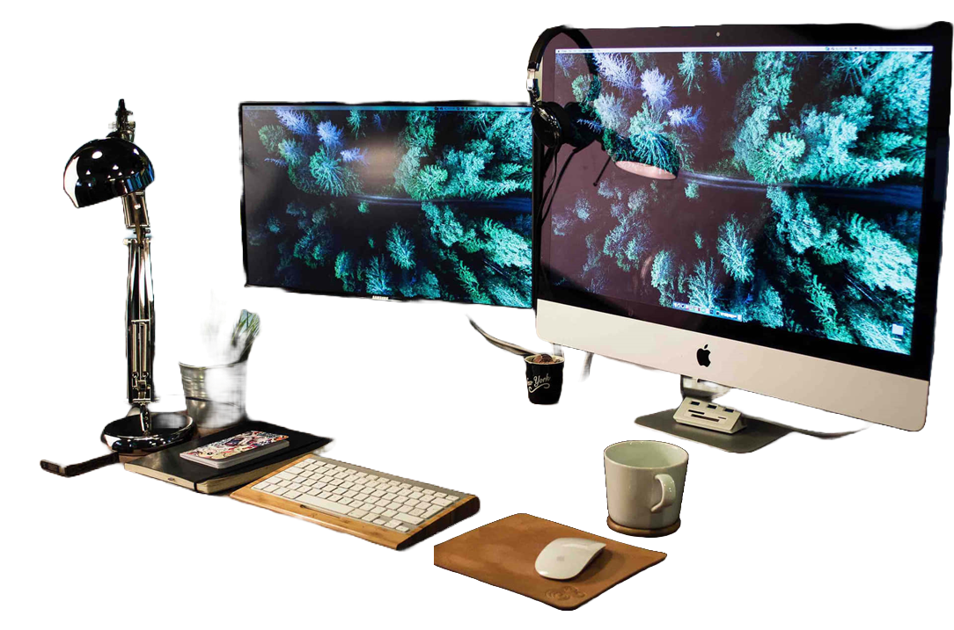

1. What is a computer?

1. What is a computer?

Answer:   
A computer is an electronic device designed to process, manage, and analyze data. It performs a range of tasks, from simple calculations to complex operation, based on user instructions.

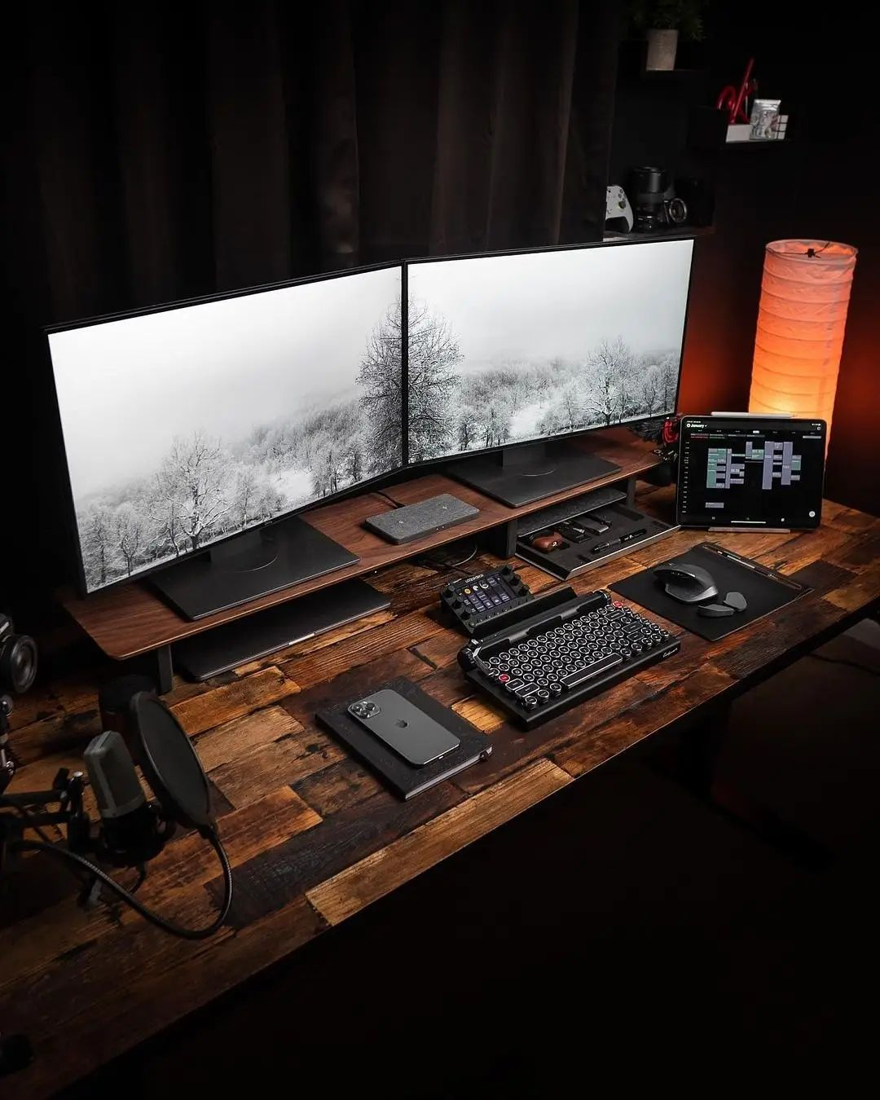

**2.**

**2.**

What are the essential parts of a   
computer?

Answer: The essential parts of a computer consist of:

**Output Devices:**Monitor, Speaker, Printer.

**Input Devices:**Mouse, Keyboard, Microphone.

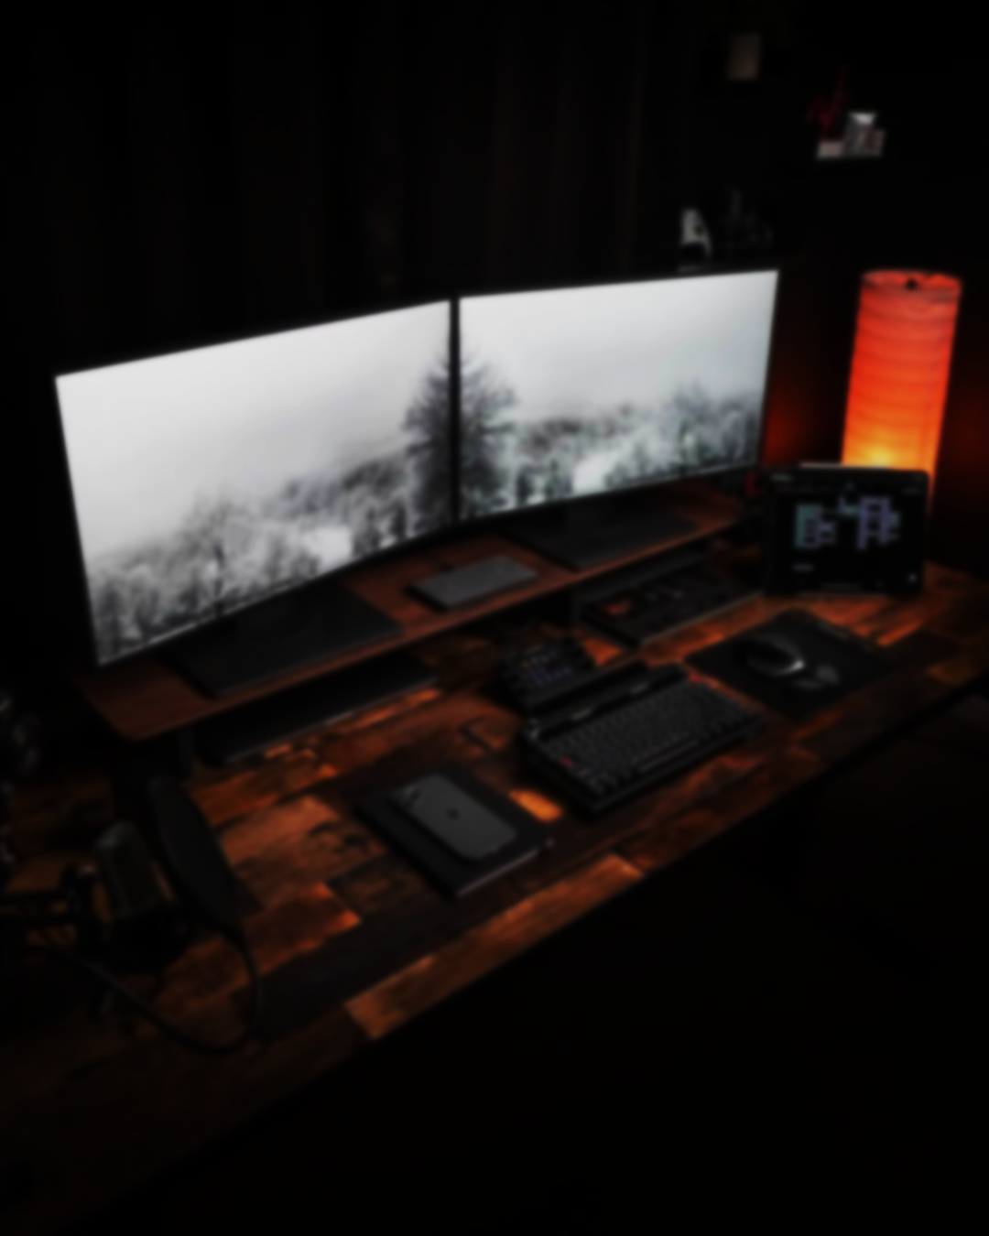

**INSIDE OF A COMPUTER CASE**

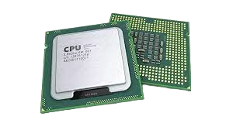

**CPU (Central Processing Unit):**  
Interprets and executes instructions from programs.

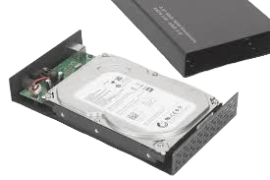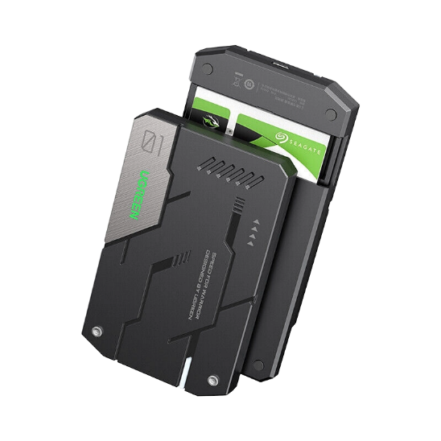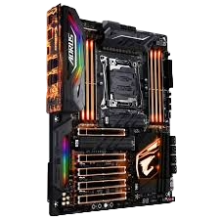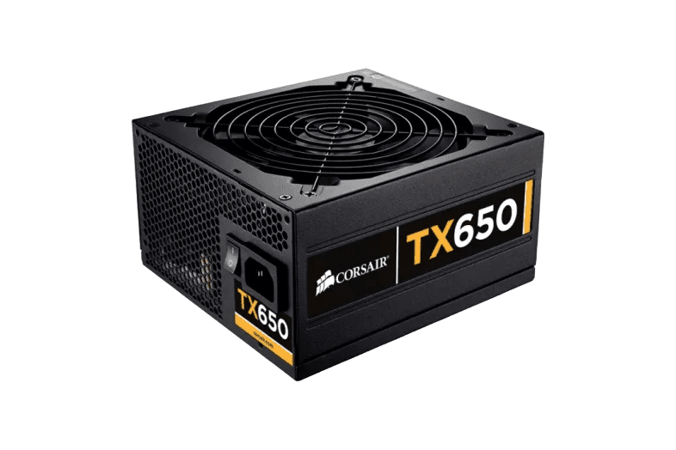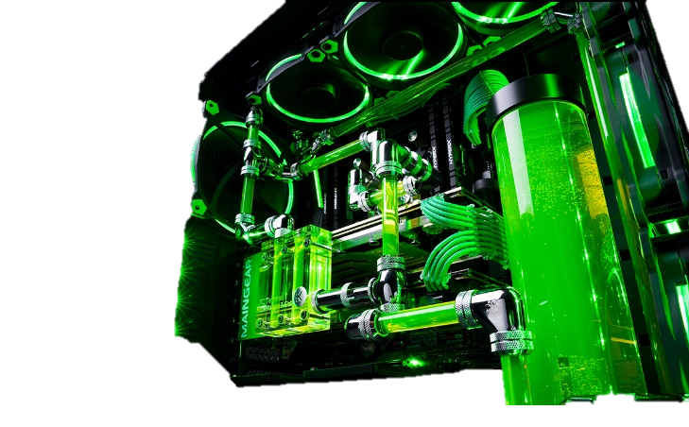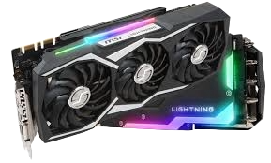

**RAM (Random Access Memory):** Temporarily stores data that is used or processed by the computer.

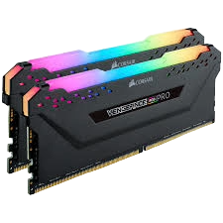

**SSD (Solid State Drive)** A faster storage device that uses flash memory.

**HDD (Hard Disk Drive):**   
A traditional storage device that uses spinning disks.

**Motherboard**:   
Houses the CPU, RAM, and other crucial components

**PSU (Power Supply Unit):** Supplies electrical power to the computer's components.

**GPU (Graphics Processing Unit):** Handles rendering of images, video, and animations.

**Cooling System:** Includes heat sinks and fans to remove heat from the CPU, GPU, and other components.

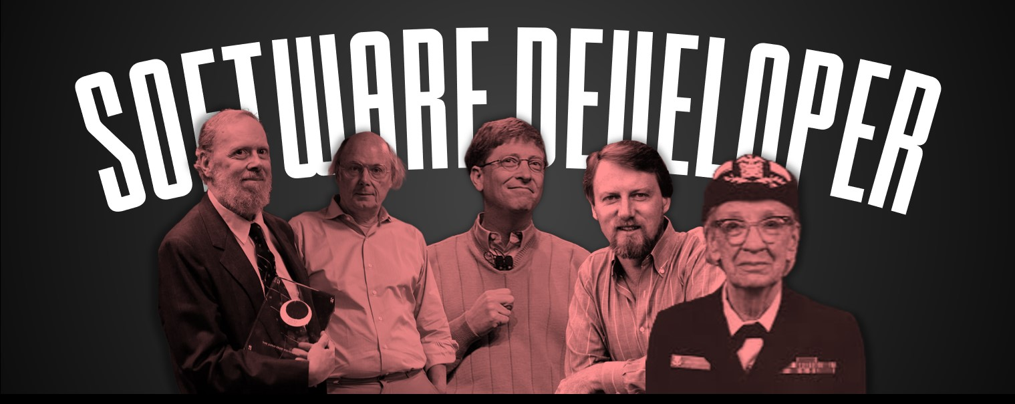

 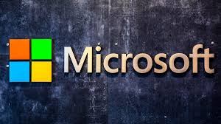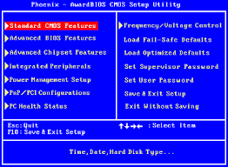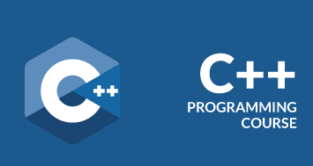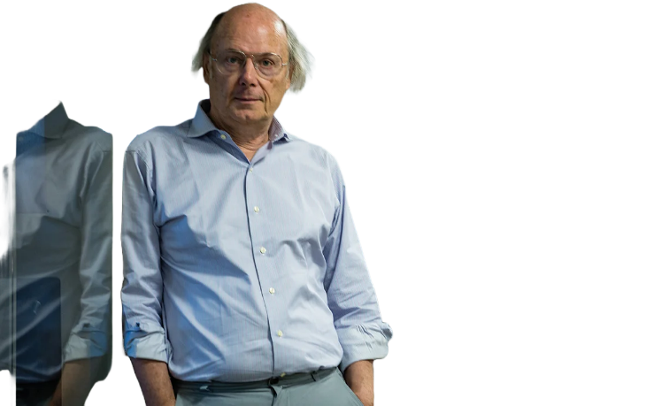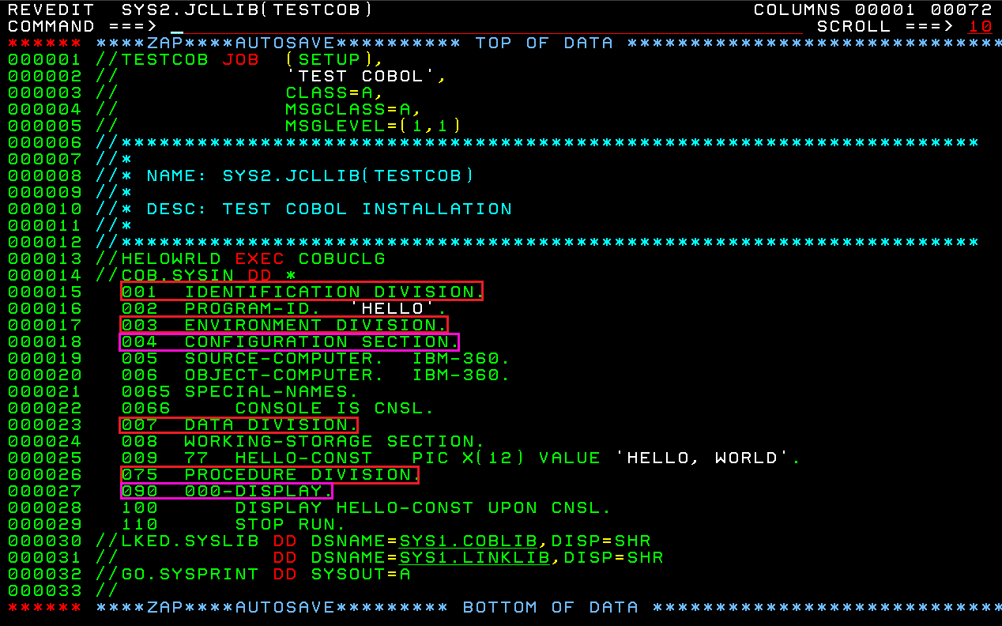

**Bjarner Stroustrup**Developer of C++ programming language, Becoming one of the most influential programming languages in the history of computing (Georgiev, 2020).

**Dennis Ritchie**One of the main developer of C languange, It used to create many types of applications and operationg system such as Windows, and other complicated programs (Ravikiran, 2024).

**Grace Hopper**One of the main developers of Mark I computer in 1944, Her team able   
to create the earlier COBOL compiler in 1952,

With the creation of COBOL it became possible for the first time in the world to create a software without having to basically tell it one instruction at the time (Quiles, 2019).

**Gary Kildall**CO-founder of Microsoft, Bill Gates played a crucial role in the development and popularization of personal computing with Microsoft's Windows Operation System and office software (Wikipedia contributors, 2024).

**Bill Gates**CO-founder of Microsoft, Bill Gates played a crucial role in the development and popularization of personal computing with Microsoft's Windows Operation System and office software (Wikipedia contributors, 2024).

**. notable inventors**

**3**



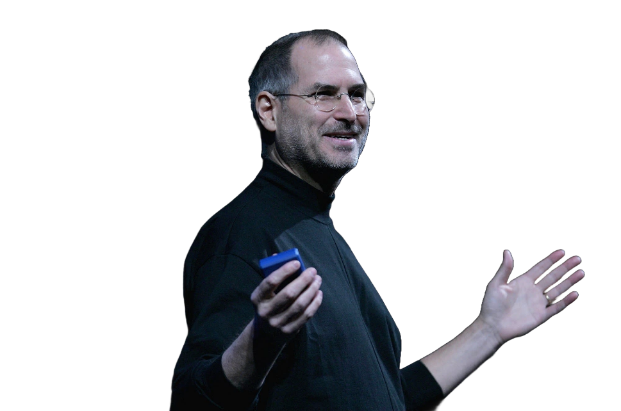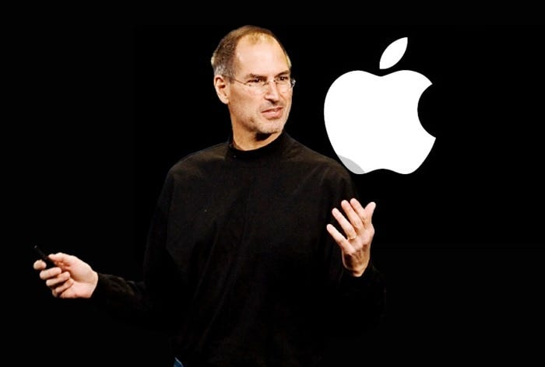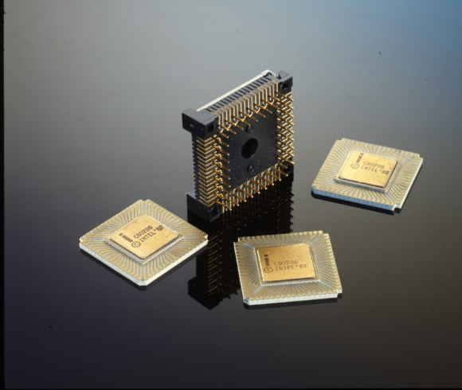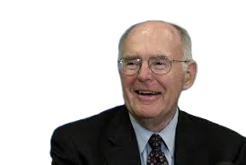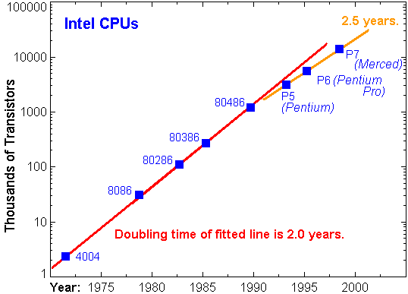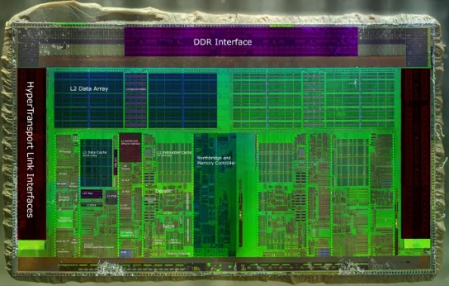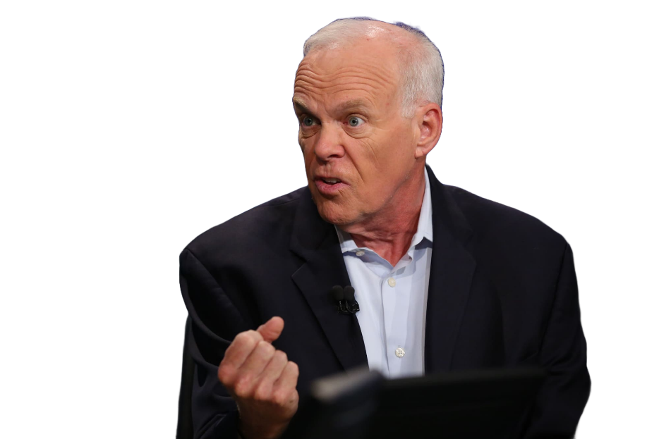

**John Hennessy**Inventory of reduced instruction set computer (RISC) chips, increasing performances of a computer while reducing cost that revolutionized the computer industry (Little, 2018)

**Steve Jobs**The creator of Macintosh, Typography on screen, Mouse, iMac(1998), iPod(2001), iPad (2010) and the iconic iPhone (Conocimiento, 2018).

**Andy Grove**Inventor of Intel Pentium Processor, A very crucial piece that impacted the development of microprocessors that power modern computing (The City College of New York, 2021).

**Gordon E. Moore**Creator of Moore's law, Co-founder of Intel Corporation, know for More's Law that predicts the doubling of transistor on a microchip approximately every two years, making power twice and cost cut in half in every two years (Science History Institute, 2024).

**James B. Keller**Lead architect of the AMD K8 Microarchitecture including the original Athlon 64m providing around 90% of the gaming performances of a single core, while being cheaper and offering all of the benefits of a dual core CPU (Wikipedia contributors, 2024b).



**4.Cite your reference/s (APA/IEEE)**

Answer. All APA 7th edition.

Conocimiento, V. A. (2018, August 29). The 5 “inventions” of Steve Jobs | OpenMind. OpenMind. https://www.bbvaopenmind.com/en/technology/visionaries/5-inventions-steve-jobs/

Georgiev, D. (2020, May 24). Top 10 software developers in the world. 💡👨‍💻 Iris - Software for Eye Protection, Health and Productivity 🛌👀. https://iristech.co/top-10-software-developers/

Little, B. (2018, June 6). John L. Hennessy. IEEE Computer Society. https://www.computer.org/profiles/john-hennessy

Quiles, L. (2019, February 1). Five Famous Software Engineers. Work With the Best. https://workwiththebest.intraway.com/blog-post/5-Famous-Software-Engineers

Ravikiran, A. S. (2024, July 23). Getting Started with C Programming: A Beginner’s Guide! Simplilearn.com. https://www.simplilearn.com/tutorials/c-tutorial/use-of-c-language

Science History Institute. (2024, April 25). Gordon E. Moore | Science History Institute. https://www.sciencehistory.org/education/scientific-biographies/gordon-e-moore/

The City College of New York. (2021). About Andy Grove. https://www.ccny.cuny.edu/engineering/about-andy-grove

Wikipedia contributors. (2024, August 3). Bill Gates. Wikipedia. https://en.wikipedia.org/wiki/Bill_Gates

Wikipedia contributors. (2024b, June 10). Jim Keller (engineer). Wikipedia. https://en.wikipedia.org/wiki/Jim_Keller_(engineer)